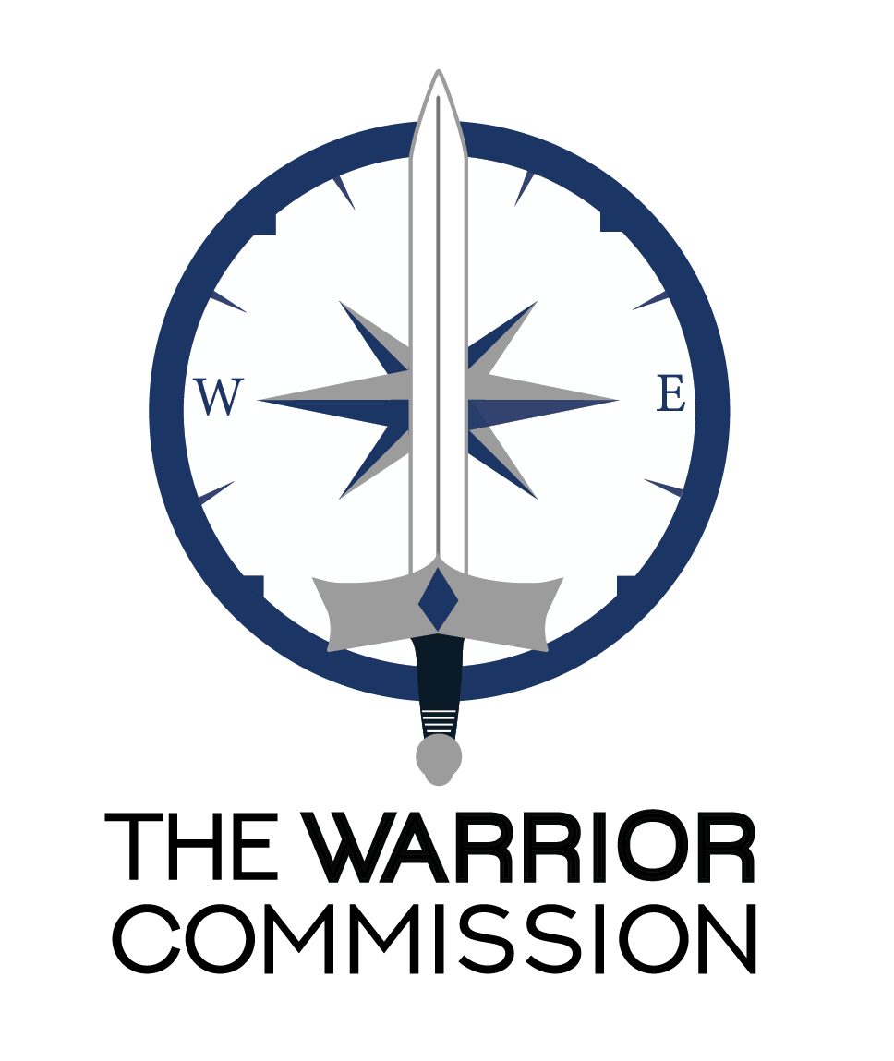
Encouraging, Equipping, Empowering

TWC
Warrior Guidebook

Welcome to our WARRIOR TRIBE!
It’s my delight to welcome you to The Warrior Commission. We are so excited you are a TWC WARRIOR! You are a part of our culture, mindsets and passion for the Lord – even if you feel like you are on a steep learning curve. We move with the Lord, so things do tend to shift and change as we partner with how God is moving.

For new Warriors, Stages 1 and 2 give you a taste of TWC and help you learn basic tools we use in many different parts of this tribe. Then, as you begin Stage 3 of our Foundations Training, you will have your mountain climbing legs ready and will start your own climb, meeting many different Warriors along the way.

God is our First Love
We are a group of people who are sold out to the Lord. We are excited about you and how your journey sparks that flame of passion for the Lord. We know that all our breakthroughs, upgrades and confidence come through intimacy - deeper relationship with Him. As you experience your own breakthroughs, we also expect you will be excited for the breakthroughs of others. After all, their testimony will probably ignite something in you, too! The fun of celebrating each other’s upgrades happens all the time in TWC. As Warriors, we share through online Warrior Chat Page (Forum), CoNexus Hubs, calls, articles, Specialty Training, Training Calls, etc. All of these are a big part of our culture of honor and encouragement.

We want to give the Lord all the credit! It’s His transforming power that moves through our training and through our Warrior tribe. He takes us from one understanding of His glory to another. He transforms us so we are able to grow and mature in the mind of Christ.

Our multifaceted training is designed to give Him PLENTY of room to pour into you. Our training is more than “doing” self-paced modules. It is ongoing in all parts of our Tribe…leadership training, specialty training. Intercession, etc. Even our leadership roles are continuation of our training and how to live it out. We do this together. Our training and exploration of God’s heart is designed to be experienced and shared with our Warrior Tribe!

We Love the Learning
One thing you will discover is how much we love the learning in TWC. We love it, not because we want to have more information – who needs more of that? We love it because we know the process of training helps us rise up as sons and daughters of God – Warriors of His heart.

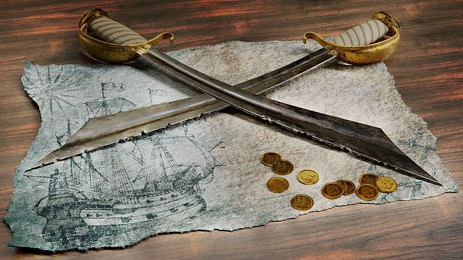
We all have missing pieces of our personal map God wants to fill with His Warrior Nature. As He does, we gain the grit, tenacity, confidence and fortitude to stand in the clash between two kingdoms and love unconditionally. It takes a Warrior mindset to unconditionally love and the resilience to bounce back when people are, well….people.

Life happens…but we decide if it happens to us or if we bring Kingdom into it. This means we train for life. We look for how to apply that training so it becomes our lifestyle. Then, you guessed it, the process starts again, but with a different way of partnering with God as we learn to live the lifestyle of a Kingdom Warrior!

Put Performance Away for Good
We know, to stand in this clash and remain in rest; to recognize the ebbs and flows, i.e. the rhythm of God’s heart; to establish a confidence in Him and in our Kingdom identity; means we train for the greatest capacity of Him in us. But, training in this type of expansion means we learn to put performance thinking aside…”have to,” “obligation,” “getting it perfect or right,” and “pressure to perform” are all put aside at this “Warrior” focus of training.

One thing we learn out of the starting gate is this: TWC is not about performing or striving to reach some lofty goal. Most of us enter TWC with an expectation of training at a high level means we work hard and wear ourselves out. Actually, that’s not Kingdom.

Training in excellence means we embrace the process of our learning and maturing throughout our training, which is a life-long journey. We allow what we gain to be established as we practice living it out. We always have more to learn because God’s heart is just that big.

Time Commitment is Your Choice
Consider what percentage of your time you can devote to TWC in each season. No matter if that is 90%, 50% or 10% of your week, just devote 100% of your focus through whatever that percentage is. Part of your training in The Warrior Commission is how to pace yourself and not feel guilty for how God wants to prioritize your time.

God has much to show us. If we stop growing long enough, we will eventually stagnate. But, we can’t keep shoving stuff in without finding a place for it to become a part of who we are. This is why we are a Tribe/Family growing together in unity with one voice and one heart. We see TWC as more than checking some training box and getting a certificate. We see this as a commission for Kingdom living as we develop personally, and together.

Think about it this way. You can only eat so much food at one sitting. You eat until you’ve had enough, then you allow your body to process and absorb the food. It converts the food to energy so you can live and be active. Then, you are hungry again, and the process repeats.

Just like this natural cycle, learning to recognize where we are in our training journey in TWC helps us know how to position ourselves. We begin to recognize if we are learning, practicing, establishing, or seeing fruit what we have “eaten” from the meaty TWC buffet table becomes an entrenched part of our lifestyle. Of course, every meal is made sweeter when shared with other Warriors!

We use the terms “flow” (learning/Input), “ebb” (thinking about what was learned and what is next) “transition” (changing from what was to what is/will be) “embedding these Kingdom things in our DNA” (establishing) and “Activating” (living it out/lifestyle). In short, God displaces our worldly DNA with His Kingdom DNA to create Kingdom thinking, perspectives, language and action. More of God’s heart in more of you. No way we can go wrong with that!

Our Real “Agenda”
Ultimately, what we hope, above all things, is for you to have a growing, dynamic and deep relationship God. We link arms as we share what God reveals to each one of us to launch each other into more. We also know, as He draws you closer into His heart, you will discover confidence in your identity in our God as you uncover, discover, explore and live out the Kingdom destiny He has for you – how you have learned to love – Him, others and yourself.

Welcome to this incredible adventure. We are so glad you are a part of our tribe.

Already Celebrating Your Breakthroughs,
Christine Casten
Executive Director of The Warrior Commission

How to Find Stuff

1 Your Incredible TWC Experience

2 TWC Tribe: Our Band of Brothers and Sisters
2.1 Warrior Culture
2.2 Partnering with How God’s Working
2.3 Raising Up “Marathon Runners”
2.4 Warrior EPIC
2.5 Safe Place to Grow
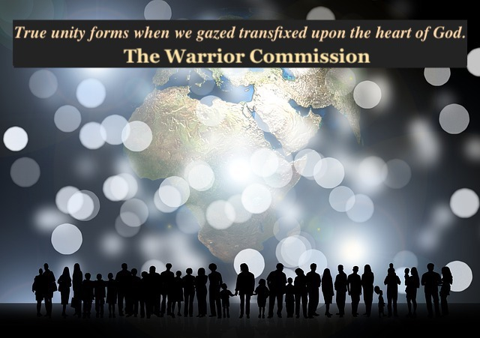
2.6 We Value You

3 How We Train/Self-Paced Training Modules and Calls
3.1 Unique Environment
3.2 Your First TWC Training Modules
3.3 Permission to Ask Questions!
3.4 Your Invitation to Pace Yourself

4 Many Ways to Train, Connect, Explore and Grow
4.1A Member Access Website
4.1B Forum
4.2 Training Calls
4.3 Zoom
4.4 Recorded Calls
4.5 What did they just say? -- Unique TWC words
4.6 Publications and Call Blasts
4.7 New Member CoNexus and CoNexus Hubs

5 Intercession/Intel
5.1 The Unique Landscape of Intercession/Intel
5.2 A Couple of Words you might want to know
5.3 In Case You Are Curious
5.4 Intel and Intercession is a Training Ground

6 Where to send questions/training modules and how to get your next training module.

Your Incredible TWC Experience!

You've already explored a great deal in your life. Now you will bring that to the table and, hopefully walk away with more! Welcome, so glad you are a part of this Warrior EPIC Nation. Congratulations!

Spend time getting familiar with who we are as Warrior Ambassadors of God’s Love and the resources at hand. This is an ongoing process. We continually add, upgrade, refine and adjust as we partner with God. We know it’s easy to move into status quo mindsets. We keep our spirits sharp and our passion alive by always being ready to pour what we have learned into our training and language.

This Guidebook is updated to reflect the latest information about our resources in The Warrior Commission. It should be helpful to equip you for all that is ahead. Whether you are a “seasoned” Warrior or a brand new one, this Guidebook is your go to resource for where everything is and how to connect to it.

TWC is a process and a tribe, not a study course. We are learning what it is to be commissioned Warriors who further Kingdom, rather than students in a class or bodies in a chair. We are maturing so we can live from the commission He has for us…Commission has multiple meanings: Co-mission with Him; Co-mission together; Commission: permission (freedom) to be and become in intimacy with God; Commission: freedoms, authority and empowering we have in God to bring heaven to earth as we carry His glory to the ends of the globe. Most of all, commission is an invitation to be all God created and live life to His fullest passion for you.

Section 2: TWC Tribe: Our Band of Brothers and Sisters

2.1 Warrior Culture
Since 2011 when we began, we discovered that Warrior nature is developed because you accepted the ongoing invitation to connect, ask questions and explore with us. Connection is ongoing, no matter where you are in your training. We have found the connection to other Warriors keeps our iron sharp and reminds us to live out our Warrior training. God’s transformation is established through relationships and connection.

Our Warrior culture came from our relational connection, or intimacy, with God. We tap into Kingdom and bring it to earth, first in our Tribe, and then to others beyond our tribe. It’s easy to step out into a negative, defeated world and let it bring you down. Most do not know how to refocus on what God is saying or be continually reminded of His promises in their life.

Even the most seasoned Warriors can find that encouragement, over time, exposure to constant negativity can wear us down. We can forget the many spiritual tools we have, at hand, to invade the earthly-minded culture around us. Staying, connected to a group of intentional and joyful Warriors reminds you who you are in Jesus and helps us all stay sharp and resilient.

Plus, our Warriors are always growing and sharing what we have discovered. It’s more than iron sharpening iron, it’s also encouraging each other in a safe, proactive and excited dynamic of what’s possible with God.

2.2 Partnering with How God’s Working
We do not rescue you from the challenges and tension you may feel in your training process because that actually steals from what God is working out in you. But, we are always available to help and support you as you go through your process of growth and walk out the transformation God opens for you – especially in the first few months of your training. Truthfully, it’s an ongoing process, because God is a transformational God!

Often the things that trigger as you not to connect as you consider whether or not to send an email to our coaches, or post on our online Warrior Chat, are negative mindsets or lies. The Lord brings them to the surface so He can shift them. Yahoo!

What??? Yes, that’s right. We are already countering those negatives and encouraging you to be encouraged! We have the most welcoming, excited, encouraging community you may ever experience.

We love to jump into conversations and there is no failure here…just opportunities to learn! So, let’s just take a minute to address a couple of the lies with the insteads of His Truth and the truth of how we see you in TWC.

You are loved. You are valuable. You have a voice!
You are amazing! Yes, we want to connect with you.
God’s placed His courage in you, so “get your brave on” and take that step
Yes, you GET to choose to connect online in our Warrior Chats, on the calls, etc.
Do you feel empowered, yet? Great! This is just the beginning!

2.3 Raising Up “Marathon Runners”
One of the things we all learn as we enter The Warrior Commission is that this is not a sprint. Performance and perfectionism are two of the main mindsets we are always countering. We are in this for the long haul, so let’s just pace ourselves! Marathon runners train to go the distance.

This not about rushing through or checking boxes. Training with God in The Warrior Commission is about transformation (becoming more like Him) and intimacy with Him. That transformation takes some time to get your head around, practice and activate. Our TWC training is about discovering who you are in Him and learning to live from a place of rest IN Him. We feel God brings the transformation and TWC helps you navigate all the transitions that come because of it!

You become a Warrior as you develop the Warrior nature required to balance the love of Father, Son and Holy Spirit with tenacity and focus bringing Kingdom to earth requires. God can do it in an instant, but often does it more slowly (our process) as we move through training modules and then practice living them out.

2.4 Warrior EPIC
We are unified in our God through our unique perspectives and wiring. We each bring something different to the table. We connect through our Kingdom Assignments based in our purpose, call and Kingdom destiny.

Intimacy with God and through God!

We are Warrior EPIC!
Warrior, Explorers, Pioneers, Influencers and Champions.
As we practice making the transitions our transformation brings,
we are becoming transition specialists!

We are not trying to conform to look exactly like each other. We all view the training through different lenses and a vast variety of backgrounds and cultures. Some things may be easier to understand. Other things may challenge your thinking and create some places of tension in you. Awesome!

Tension just means you have something to explore with God. That tension is usually there right before you breakthrough into a new revelation of Him…so keep pressing in by resting in Him. God brings transformation in our lives. As He does, we learn to transition in our thinking, language, habits, way we see from God’s heart and how we bring Kingdom to earth. These are the Evidence of Our Transformation (EoTs). You will have a chance to explore these in your self-paced training modules.

2.5 Safe Place to Grow
We spend a lot of time training our leaders and fellow Warriors in how to create a safe environment to learn, take risks and explore. We don’t see a misstep as a failure. We see it as a learning opportunity. At the same time, God is kind. We hope to tap into that kindness in the midst of calling each other into more, unlearning what is not aligned with God’s heart and/or reframing (or having a better thought that more closely reflects the way God sees things).

Many who come into TWC have hit some walls in this area. It takes courage to trust us after some of those past experiences. But, just watch how many are overcoming, flipping those past negatives to a place of strength in God. See how many Warriors are finding great joy as they take risks in their learning process and growth in the Lord. Rather than bitter roots, those negatives become areas where we can grow in compassion for others.

2.6 We Value You
Extroverts and Introverts alike may feel a moment of pause…but, the answer is yes, you ARE a part of our Tribe and we want to get to know you. Sometimes even our seasoned Warriors need a reminder of this - You do have a voice and we value it!

We value you where you are and who you are becoming in Christ. We already think you are great and that won’t change, no matter how brilliant you FEEL your post or email is (or is not)…no wrong questions here! We get excited when you get your brave on and post or email.

Instead, consider this a way for your boldness to develop and for us to value what God is doing in your process. We love you enough to encourage you to reach out to us with any questions you may have! We are an invitational culture…the invitation to step outside your comfort zone is always on hand.

Section 3: How We Train/Self-Paced Training Modules and Calls

3.1 Unique Environment
We have a lot of options and elements that will be a new adventure for most people. You get to begin right now! Your TWC training contains some terms and concepts that may be completely new – and we do add a few more here and there as we all grow in the Lord. Keep your chin up! You are learning more about the TWC Kingdom culture we are so excited to share.

You are not expected to “adopt” these terms into your own life, but we use them in TWC as shortcuts to describe larger pictures of how God is moving. We have a Quick Guide to TWC terms you can find on our TWC Kingdom Culture tab on the website (you need to be logged on to see these pages).

If you are like the rest of us, you might need to read sections of your self-paced training a few times. Yup, they have some depth in them that might take a second, third or more pass through to capture. We have it packed with years of exploration, discovery and what we’ve learned on our journey. Then, you get to activate in (practice and walk out) what you just discovered!

We love the learning and all this stuff is a chance to get familiar with what God has put on the TWC buffet table for you to enjoy!

3.2. Your First TWC Training Modules
It’s time to develop your TWC and personal Foundations!

Foundations Training is divided into 6 Stages. Stages 1 and 2 are focused on new members and are a taste of TWC and Kingdom culture. They give you a peak of what is coming, while helping you understand what will continue to build in you. Consider them an appetizer. They give you a chance to embrace our TWC culture and equip you with the basic tools you will use throughout your Warrior Commission lifetime.

Once this part of your journey is completed, you will move into Foundations, Stage 3-6 which are an integrated training of relationship with Father, Son, Holy Spirit. Here we expect you will gain more freedom, confidence, identity statements, Impact prayers, etc. (see the website for more) as you journey through each one.

In addition, most of the extra materials you purchase for this training, and in other trainings, have similar kingdom concepts stated in other ways. It’s important to us that you have a multitude of voices speaking into your life. We all have a unique wiring and sometimes the same thing said a different way will click better for you. We have a lot of depth in our resources and many different ways to mine them for treasure and then apply them. So, you are also building your library of resources.

3.3 Permission to Ask Questions!
Please feel free to ask questions. You will have many along the way. We love questions! We have a team of coaches ready to support you. twc.warriorepic@gmail.com.

The most updated version of this Warrior Guidebook is located on the member only side of our website: http://www.thewarriorcommission.com/ under the Training/Warrior Helps tab. If you lose this one, or want to make sure you have the most recent information, you can refer to it and/or print out another one.

3.4 Your Invitation to Pace Yourself
Note about this training and all of the different types of Foundations and Advanced Training Modules in TWC training. We give you suggested time frames. Some people like to pace themselves in this way. Others, may not. No worries. Foundations 1 and 2 has a suggested 4 month completion process, if you stick to the suggested timeframe.

This means you get to pace yourself through it and determine if you finish more quickly or take more time with it. You also do not have to wait if you miss one of the calls associated with any of the self-paced trainings before going on. Keep going and catch the call at another time.

What do we mean? If you are unable to attend the Month 1 call, just keep going in your training and catch the recorded call (Call Library tab in the Warrior Chat page on the Forum) or catch the next Month 1 live call. No reason to stop your momentum!

Most of our training modules are self-paced. Part of the seasoning you gain in TWC comes as we invite you to be proactive, reach out and connect. We develop you in a way that builds you, and, ironically, (on the surface) can sometimes FEEL like we aren’t here -- but we are and we’ve found this process sees confident, strong, passionate Warriors rise up! We have many who are making an impact in many different areas of influence…local to global. They discovered, or reconnected, to the God dreams in their lives and are living them out!

It may take a bit of time to get the pace of how TWC does our training. We are very intentional in how we set things up. Even some of the advanced specialty trainings we have that DO have specific due dates are put together that way on purpose. In these specialty cases, the due dates are actually part of the training. -- And don’t be concerned, we will give you a head’s up if that’s the case!

But, just know, we believe our training is not merely informational, but encourages a lifestyle of relationship with God and each other – Intimacy with God and heart felt connections with others through God. We believe that we rise as you rise. You rise as other Warriors rise. As we rise together, we will see heaven come to earth in all our areas of influence. This is what creates a Warrior EPIC Nation!

The one who knows Him becomes a Warrior in Him!

Section 4: Many Ways to Train, Connect, Explore and Grow

4.1A Member Access Website
Our Member side of our Website is YOUR Resource Library. There's a lot here. Choose a section and familiarize yourself with its contents so you'll know where to go when you have questions. It’s huge! You will find too much to absorb at once. This is part of our TWC Buffet Table. You can’t put it all on your plate at one time! Just use this time as an overview and jot down what you may want to dive into at a later date.

Here are a few options in our Website:
- Explore the Training Journal Archive. Training Journals are a rich resource and come out periodically to focus on specific areas of growth and training (Publications tab)
- Look through our Frontline* Archives to get a greater sense of the journey and story of TWC. Frontlines are mini training journals and come out monthly. We put each journal with its focus in this tab. (Publications tab)
- Check out our TWC Values & Principles or Decisions That Define Us. This will give you a great sense of our culture. (Footer or TWC Kingdom Culture tab)

4.1B Forum
The Forum is here for you to connect with others in TWC. This Facebook-like connection allows you to access our Tribe and our members directly through email and direct messages. You will also find your account, ways to personalize your picture and background, and much more. For more information on other ways to find connection, click here.
- The Warrior Chat page is where we all come together. It’s here to encourage, equip and empower us in the joy of a Warrior’s life with God. This page brings us all together to celebrate each other’s journeys, post recorded calls (Call Library tab), find call links (Events tab), make announcements and connect.
- Website Forum Groups are an incredible place to connect with smaller groups and celebrate all God is doing. Most are specific to a Specialty Training or CoNexus Hubs, so people move in and out of those pages, depending on if they are in that training/group or not. Not all pages are accessible, unless you are participating in that specific training or Hub. But, don’t worry, you will have a chance to be in a specific Hub or training as you have time and space.
- Forum email notifications – Notifications are automatically set to real time. This means that for every group you are able to access, you will receive notifications each time someone posts. If you choose to decrease the frequency, you may need to proactively check your groups to make sure you do not miss posts regarding upcoming calls or group discussions.
You do have the option to change the frequency or stop all notifications.
  - Log in
  - Find “My Account” (orange word bar at top of website) and click to link
  - Find the left tab under your profile pictures labeled GROUPS and click to open
  - Scroll down to see all the groups you are able to access. (side note: You can connect to those group pages here by clicking on group name)
  - To the right of the group name you will see, “Your email status is (change)”
  - To the right of this sentence, you will see “All Emails”
  - Click the orange word change to select one of several options
    - No email
    - Weekly
    - Daily Digest
    - All emails (real time notifications)

- Below are the Forum Guidelines for posting. You can also find them here under the TWC Kingdom Culture/Connection tab: Click here - https://thewarriorcommission.com/access/forum/general-use-guidelines
TWC FORUM GENERAL USE GUIDELINES
THANK YOU FOR SHARING YOUR VOICE!

The simplest way to know if something is "a go" to post consider: Does this post share to how God is transforming me through my TWC training? Does it celebrate how I am growing and facing transitions in my life? Basically, we want to brag on God and celebrate your transitions, mindset shifts and how you are becoming a stronger, focused Kingdom Warrior. For this reason, we ask you refrain from posting quotes/messages, etc. from well-known people on the website pages - our Forum is not about what someone else has to say, it's about getting to know you and what God is doing in your heart that we can celebrate!

Note: Each time you create a post on the Forum, a notification email is sent out to those who receive real time notifications. We love for you to share your thoughts, but encourage you to consider creating no more than one or two new posts a day.

However, full freedom to respond to as many posts as you are able to as that encourages the person posting and sends them a notification that you have posted (if they are set up for real time notifications). Responding to a post does not generate an email to the whole group

OUR PRIVATE TWC FORUM PAGES INCLUDE:

- Member responses related to TWC training
What are you discovering? What is God doing? How is He moving? Feel free to share!
- Share short stories of ways you are turning your training into a lifestyle? 4-6 sentences max appreciated
- Ask questions that spark dialogue in our TWC community
- Share your Identity Statements & Inheritance Scriptures
How did you receive them? What limitless possibilities do they open up for you?
- TWC wide and TWC local gatherings - pictures and updates
- Thoughts, discoveries and breakthroughs from Training Calls
- Your discoveries from our website library and/or training videos from coaches and veteran members
- What is sparking deeper connection with God?
- Thoughts from our public blog posts, quotes or questions.
- Welcoming New Members
- Impact Prayers from our Blueprints
-Link to a worship song that inspires you
- Feel free to encourage, edify and positively pour into our Warriors
- How God is moving in an instead in your life
- Pictures should have a short story, evidence of transformation or something tied to God's heart moving in your TWC experience

WHAT TO SAVE FOR YOUR PERSONAL SOCIAL MEDIA PAGES (PLEASE REFRAIN FROM POSTING IN TWC)

- messages, sermons, quotes, blogs or video links*
- political statements or inflammatory comments
- advertisements, news articles, etc.
- promoting your own personal ministry, blogs, pages, books or videos without submitting it for approval*
- unless you know a member well, and get permission first, please do not solicit, advertise or request member involvement in personal projects
- requests for personal funding, GoFundMe, or solicitations for financial support for any person or cause
- problem focused posts - stay in “Chair 1,” i.e. heavenly perspective and focus on what God is doing instead

If a post needs to be removed for any reason, we will contact you and let you know. We will give you grace for the learning process, but will remove access to the group after three removed posts in a 6 month timeframe. We are a family that encourages, equips and empowers - negative talk, anger or frustration about any other member or leader within, our outside of, TWC will not be tolerated. In addition, our member information is private and we do not give permission to share or sell emails, phone numbers or personal information of our membership to third parties.

PERMISSION GRANTED: By posting on the TWC Forum pages, you give permission to have your post included in any TWC materials, training, publications, media, social media and promotions.

YOU ARE WELCOME TO MAKE FRIENDS & CONNECT OUTSIDE OF OUR OFFICIAL EVENTS, however, use wisdom. The Warrior Commission is not liable for meetings of members. Any connection to members are up to the discretion of each member.

*If you would like to post something of this nature, submit what you would like to share along with your thoughts on how it relates to how God is moving in your life and/or your TWC training. Send the full article, link etc. to twc.memberservices@gmail.com for permission to post. Also understand, we love having cross pollination in the body of Christ, however, we cannot thoroughly “vet” every person who is sharing something with one of our Warriors across the globe. However, you have the opportunity to consider how what they said sparked your heart, take it before the Lord and share how you conversation with the Lord is provoking your thoughts and growth.

4.2 Training Calls
How do I know when the calls are?
- Our video (conference) training calls are listed on the Events tab on the Forum – Warrior Chat page. When you open the tab and see the event, you can click on the calls you are interested in attending to find out more. Then you can create reminders on your personal profile.
- Email reminders sent every Thursday with the calls for the next 10 days.

You can join any of these calls, but we encourage you to pace yourself! The Foundations calls are your priority! One will be held each month for each Stage.

When would be best to join the Foundations Calls? You are welcome to join any time look for information on what training the calls best support.

4.3 Zoom
We use Zoom as our conference call host. Before your first call, you will want to make sure you have the app downloaded or have found the online site to work out any glitches (like permissions for audio and camera access). These calls can use the camera from your computer, phone or iPad. (You can also use the call in number from your phone.) Of course, you can simply follow the call links in the Warrior Chat (Forum) Events tab or in the weekly Call Blast Publication.

You are not required to use the video option, but it does allow us to see each other and is the closest we get to face to face connections, other than our live gathering events. Some of us also like to use earbuds for the calls to block out extra noise.

4.4 Recorded Calls
We record all the calls and this is why: With all the time zones of our Warriors across the globe and the busyness of our normal daily lives, it is very likely that someone will miss a call. We post the recordings on the Forum in the Warrior Chat/Call Library tab so anyone who missed it can listen and gain from it.
Also, Warriors who are in different modules of training often join calls geared toward earlier training modules to refresh themselves on Foundational concepts AND meet new Warriors!

4.5 What did they just say? – Unique TWC words
Are you trying to figure out what people mean when they say “altitude, base camp, love the learning, no failure in Kingdom, permission granted, the process makes us rich, Intel, upgrades” or some other word? We have words that have entered into our TWC Kingdom culture based on our training resources and prophetic words.

You personal experiences can allow words come with a lot of baggage, or be defined in more limited ways. With the many different backgrounds we all have, sometimes just making sure we are on the same page makes a big difference in expressing ourselves or understanding what someone else is trying to share.

Check out our Quick Guide to TWC Terms in our website under the TWC Kingdom Culture tab.

We do not expect you to “use” these words, we just want you to understand them because we use them a lot! : ) We want you IN the loop.

4.6 Publications and Call Blasts
Each month we send out two publications and weekly call blasts to our Warriors.
Want to know a real time, most updated 360° view of TWC? THIS is how you keep your fingers on the pulse of what God is doing.

Because we are a prophetically inspired group and are Kingdom explorers and pioneers, we are always finding something exciting that God is doing. These may come out through a prophetic word someone shares, a new training, a call, through a CoNexus Hub…God is creative and releases things through all His Warriors. We seek to partner with Him in rest and see these Kingdom, heaven to earth, things established in our tribe. That means things do change, we keep moving and this is the best way we know to keep everyone in the loop.

Each of these publications are rich with the latest breaking information to encourage, support and connect. They are sent to your email and are posted on our Facebook page.

- Frontline: As a Warrior you are on the front-line of the clash between two kingdoms. We create articles to positively encourage and challenge you as you train. These support your growth, offer highlights to help you and create spotlights of our members. Over time, these publications contains many different voices from our community and are often on the cutting edge of what God is doing in TWC.
- Warrior Update: Intel and What's Coming. Warrior Update contains training for Intel (prophetic intercession), the current Impact Prayer focus we pray as a community, feedback from our Prayer Focuses (Blueprints), and the most updated information on face to face gatherings, upcoming events and announcements.
- Call Blast: Sent out weekly. Reminder of the upcoming calls for up to 10 days out.

4.7 New Member CoNexus and CoNexus Hubs
As you know, we are a tribe, well really a Warrior EPIC nation made up of many different tribes. We are still exploring what this looks like and means for us. CoNexus (said like this: “connects us”) are groups where our Warriors can form the deeper relationships and find running mates on this journey together.

As a new member, we have a CoNexus Hub that focuses on your Stage 1 and 2 and helps you with any questions you may have about TWC. It’s a great place to connect to others who are on a similar part of the journey and also have a dedicated coach(es) who will encourage you in a group format.

After you begin Stage 3, you will have the option to transition to one of our ongoing CoNexus Hubs. These groups meet monthly. The facilitator commits to leading it for one year. The focus of the group is to build relationship with each other, but taps into specific areas of prophetic intel, Blueprints, etc. This allows the prophetic words spoken over TWC to be stewarded, but also opens up more conversations of how you can connect through them to God’s heart for you, your identity in Christ or just normal life journey experiences of how to live a Warrior lifestyle.

These groups form each year in a “blind” reforming. This means that you pick the day/time that work best for you. We pray the Lord will draw those who are meant to connect. We hope the year will see you form wonderful and lasting friendships. The group “unforms” in June. You will get to join a new group that reforms each July. This gives us all a chance to get to know each other well, for relationships beyond the group meeting and counter any tendency we might have to form cliques.

Section 5: Intercession/Intel

We believe prayer is powerful. We have seen too much evidence of God moving through prayer to believe anything else. Our journey is not so much about throwing prayer at God and hoping we get it “right”, but more about how to connect to what God is already praying and partner with that!

Don’t you want to know what Jesus lives to make intercession for in Hebrews 7:25? Wouldn’t you want to connect with Holy Spirit so you know what to pray in Romans 8:26? Don’t you want to learn what it’s like to pray without ceasing, highlighted in 1 Thessalonians 5:16-18?

THAT’s what we are training in as Warriors who have a lifestyle of intercession. Intercession is not what we “do.” Intercession is who we are…because prayer is relational with God. We only become confident in who we are through relationship with Him.

If you have questions: You can contact coaches at any time. They love to help and are passionate to make sure you feel supported! We will take the time to explain and make sure you are comfortable with your understanding. We have coaches who are excited to help you and are dedicated to making sure you feel encouraged and supported! You have no idea what a delight it is to help you out!

If you are in Stages 1 or 2, just put your training module/stage in the subject line of your email so we make sure we know you are new to this. And remember to give us your name if it is not part of your email.

Another option...Our Warriors LOVE to help you out, too! We know what it's like to be new and discover. Our Warrior Tribe is amazingly helpful and absolutely love to pour into you!

5.1 The Unique Landscape of Intercession/Intel
Prayer is very unique in TWC. TWC actually started with a question of “what would happen if a group of people/warriors trained on the ground of intercession? So, intercession has long been a foundational part of our Tribe.

Originally we focused on one person (Graham Cooke), but over time, the Lord shifted our focus and expanded our prayer reach. We have created Impact prayers for people in several continents and numerous countries, multiple mountains of influence and many different backgrounds and ages.

Rather than praying for land or areas of influence, we pray for the people in the land. Their call and passion for that land, or area of influence, creates greater open doors and permissions for us in prayer. They are the boots on the ground. We seek to partner with God to give them better boots, maps, strategy, spiritual clothing and equipment through our Intel/Intercession.

We are more project oriented in prayer. Rather than praying for one or two people in an ongoing focus, we spend a shorter amount of time focused on one specific person or group. In that time, we create something more lasting and tangible in our process. We call these “Impact Prayers.” We also go further, at times, to create a deeper and more expansive revelation document, called a “Blueprint.”

Once we have poured into that process and developed the Impact Prayer/Blueprint, we give that to the persons in the prayer focus and move our targeted intercession to our next divine assignment.

Someone in our Tribe walks alongside the Blueprint recipient. It’s about developing a relationship and encouraging them in their process of growth. These recipients are often leaders who need a safe place to process, explore, refresh and grow. We provide this along with the prophetic information in the Blueprint.

5.2 A Couple of Words you might want to know.
Intel: learning the heart and intentions of God regarding any given thing.

Intercession: standing in the gap for another as you partner with God in prayer.

In TWC, we sometimes use these two words interchangeably, but there is a difference. Put simply, Intel gathering is the act of asking God, “What’s Your heart for this?” In prayer, you gather/collect what you understand, "hear" or learn of God's heart for something, or someone, as you lean into Him. We prefer to say connect and receive, rather than “hear what God says.” God speaks to us in a myriad of ways depending on our wiring or our season. We are learning to rest in Him as we recognize what He is pouring into us so we can better partner with His heart.

Intercession is a beautiful interchange with Father, Jesus and Holy Spirit. It’s a time of intimate connection with His heart. Intercession is actively partnering with God and applying what you learned from your "Intel" through your time with God through prayer.

Prayers of Impact for our Blueprints and TWC are a matured prophetic prayer. They are created through the prophetic process of gathering Intel from our members.

Our Intel process is a unique experience of developing prophetic intercession and Prayers of Impact. Even before TWC became an official community in 2011, we trained in aligning with God's heart for events, people and places.

5.3 In Case You Are Curious
In 2015, we discovered a way to target our intercession through "Key Territories." God is, as always, amazing. Over the years we found 8 common themes rose up through our prayers. We call them, "Key Territories." See Publications/Training Journal tabs and find the Training Journal 15.

As we explored it, we realized we can apply these truths and scriptural foundation to each of our lives, to our TWC tribe and beyond -- to leaders, churches, businesses, cities, regions, nations and, even globally, on international levels.

Key Territories are like diamond mines. We still have a lot of gems to explore and dig out. Even now, several years later, we know we have only mined the surface of all the depth still available in each one. -- As part of this Warrior Commission special forces community, you will have opportunities to know these better. Just get a taste of them right now.

As God began to expand our boundaries, we realized that we are Kingdom catalysts in the area of Intel. The Lord has opened the door for us to encourage Christian leaders who operate in many different areas of influence through our Intel process. We all, you included, have a chance to contribute to these "Blueprints" at different times throughout the year.

Once you enter Foundations, Stage 3, you are randomly placed in a Intel Gathering group. Throughout the year this group receives an Invitation to participate in Intel as part of your contribution to TWC and the Blueprints and/or Impact Prayers we create for others. According to our Warriors, choosing to accept the invitation opens many different upgrades within your own training process. Typically, the group does not work together. However, as the Intel is gathered, you do have an opportunity to receive specialized training and become a part of the advanced team.

Our Intercession continues to evolve and we have some new things to apply to our Key Territories. But, even with its far reaching effects, the central question never changes. We simply ask God..."What is Your heart for this Prayer Focus*?"

*The Prayer Focus is our opportunity to pray for leaders within various areas of influence that God has highlighted and connected to us. We also use this process to gain prophetic insight and develop Impact Prayers for The Warrior Commission so we can unify in prayer as we stay attuned to Holy Spirit and the heart of God. You might check out our TWC Now and Beyond Blueprint in the Intercession tab on our website.
5.4 Intel and Intercession is a Training Ground
Together, these two training areas teach us to listen more closely and capture pieces of God's heart for others. We practice learning to translate God in the many different ways He connects to us. It is different for everyone. Some will "know," others will "see," some will "feel," still others will "hear" His still small voice.

There are many different ways He shares His heart with us. Whether it is through scripture or a God-given dream or vision, we all have the opportunity to learn how to understand and align with what God is sharing.
We invite all our members to join this incredible process -- no training necessary -- just a willingness to say "yes" and pray.

- You will be included in one to three prayer opportunities a year. Through this process, you, and others who are part of that invitation, will receive information about the prayer focus. That email will also include questions to help you process what you get from the Lord.
- We tap into the collective wisdom (all the submissions sent in from your prayer group participants) and then take the submissions through a developmental process. -- This is one way we value YOUR voice and give you a chance to be heard. (Proverbs 11:14)
- In case you are curious about our whole Intel process: Understand, this process continues to build and refine (distill) what is submitted into a prophetic, process-oriented Blueprint, or map. We have Warriors who have gone through additional training (Intel Development Training) and who are passionate to develop their skills. They are invited to join the Intel team and commit more time and focus to this specialized area of growth.
- This multilayered "map" opens the door to a wealth of information that is part of the Prayer Focus. The whole Blueprint takes about 16-20 weeks to develop. Right now, all of this is just information for your curiosity.
NOTE: Exploring the invitation to Intel gathering might feel awkward, or even risky, at first...just get your brave on and try...TWC is a VERY safe place to practice and learn! But, also remember, we value your power of choice. For our Blueprint development, we extend the Intel Gathering opportunities to you as an invitation, which means you will need to look at your life, and decide with the Lord if you will accept that invitation or wait for another down the line. We hope you will participate as they come, but understand if you are unable to at that moment in time.

Section 6: Where to send questions/training modules
and how to get your next training module

When each training module is complete, you will submit it to your coaches’ email. You will receive a response in 7-14 days. We encourage you to take a short break while you wait. Once you receive feedback from the coaches, you are welcome to request your next training module from Member Services.

Because of the way Foundations Stages are set up, we do not ask for you to take more than a short break/ebb between each module. In our Advanced trainings, specialty training, etc. we ask you to consider a longer ebb between each one, so you have time to practice it and let it become an active part of your life.

Send all your questions to your coaches at twc.warriorepic@gmail.com.
Send all your completed training modules to twc.warriorepic@gmail.com.
Request your next training module from twc.memberservices@gmail.com AFTER you have received feedback from your coaches.

We are beyond excited that you are a part of TWC. We believe God placed you here for such a time as this…to train, grow, heal, explore and rise! We link arms with you and believe you are emerging as a Confident, Connected and Catalytic Kingdom Warrior.

The logo, sword, compass, and compass rose (icons) and term “Impact Prayer” used in this publication were created and designed for the sole use of The Warrior Commission, Copyright ©2021 by The Warrior Commission. The Warrior Commission retains exclusive rights to these logos in whole, or in part. These icons may not be used worldwide or in the United States, together or separately, for any other use without express written consent by The Warrior Commission. Used by permission. All rights reserved. TheWarriorCommission.com.

