February
Key Territory: Empowering Grace – New Testament Nature of God

Time to See a Return
By Ted Mather

Key territories, as defined in The Warrior Commission, are specific areas targeted for intercession. They were identified in the early days of TWC through intel submissions given by every member. (You can access Training journals 15 and 16 for more details). We, as Warriors, are training to become proficient in intercession to take ground in these territories. When you train you will develop the skills and giftings God created in you. That development will manifest internally and externally. God has given each of us every tool we need to send the enemy running. Our training helps us learn how to use those tools.

When I was 16, I remember a day after school. I sat with thirty-five other boys in the locker room dressed in our football gear. Bright eyed and bushy tailed the coach stood before us and said (paraphrased). “Welcome gentlemen. Welcome to the training ground for your future. When you come onto that field you will experience pain and exhaustion. But worse than that, you will battle doubt and that will make you question. This is the battle in your mind. To win you must decide to train and then step into it here.”

Whether you make the choice to train, fight or turn away, every training you complete will take you closer to Jesus and grow you in your journey. Today we are facing a place in our journey where we must make a decision. This is the New Era and we have been given territory which needs occupation. That sounds overwhelming but that is what the training is all about. You are spending time developing your identities and cultivating intimacy with God. Everyone who has been in TWC has come to that crossroad and had to decide.

TWC offers you an invitation to take that ground internally and dig into your maturity. This can be a life changing opportunity to know the Lord in ways you never thought were possible. Join all the calls you can. Be active in your Conexus group. Send in words you get. Ask questions of your coaches. Post testimonies and words of encouragement on the Forum. The forum is not too difficult to navigate. Use it, it is a valuable resource.

You are a Warrior and you were Chosen to join this group. You committed to invest in this group with all of your resources and in your own development and transformation. Now is the time to see some return.

Grace Gives and Grace Calls Us Up – by Christine Casten

Recently, I went to a conference. I was excited about exploring and cross pollinating beyond my amazing Warrior Commission Tribe. I also had a newer friend who planned on rooming with me at the event. So, as I drove to the venue, I was expecting some good stuff…and, yes, as the unexpected happened, the Key Territory of Empowering Grace provided insight to live in authority, rulership and God’s powerful presence.

One of the speakers was a fiery woman, a person who strategically maps, then fights, on the spiritual battle ground of intercession. After her talk had ended, I went to lunch with my roomie.

On the way, she talked about how jazzed she was by what that lady had said. Then, she said something that was meant to cut me down. Surprised by her approach and realizing I just got slammed, I entered the ground of Intercession through the Key Territory of Empowering Grace – for me first, then for her.

I started with me because focus on my internal territory allows me to be quick to forgive, wise in my words, and dedicated to internal peace in God. Yes, it takes a moment, but the internal ground must be shored up before I can walk in grace-filled authority.

Regardless of the crazy that moment was, overcoming personal limitations or wounds opens up an internal fortitude, resilience and passion that means I can take the external spiritual, ground before me. Doing this in my inheritance, as God’s daughter, involves living out the rulership He offers on this earth.

God’s empowering grace took me through months of conversations on the difference between immature and mature warriors. God opened up the internal vs external framework for what a Warrior looks like to Him. He emphasized how a strong code of honor is rarely lived when warriors are raw, immature, and trying to prove themselves.

In fact, grace is defined as this: do honor or credit to (someone or something) by one's presence. Empowering Grace honors our commitment to Him. It credits us with His presence and strengthens us because He is with us – each moment, each situation, each battleground of life.

When we walk as one with the One, we do honor and give credit to God because His empowering grace is His presence moving in our lives. Grace gives Him, fully present in us, just as it makes a way for us to be fully present in Him. Grace calls us up to new areas of maturity. The Key Territory of Empowering Grace empowers us…the power, authority and rulership we live are exponentially increased when lived through His grace.

How is Grace Empowering you today?

A Loving Hand – Sharon Rudolph
Empowering Grace is the Empowering Presence of God. The receiving of unmerited favor becomes God lavishly loving us. John 1:17 “For the Law was given through Moses; grace and truth were realized through Jesus Christ.” Grace is something that is realized, known, and felt, like the Presence of God. This loving hand of God that takes us beyond human self is a holding power that moves and transforms, in the kindest possible way. (2 Corinthians 12:8-9)
Presence makes all the difference in the world. Having someone there, no matter what. Every evidence of transformation written in a Training Response Journal is full of this Presence, that is, His grace. We are changed. That change is much more of how God has moved than our working hard, although it may have been hard work going through the process.
This Presence goes beyond salvation grace becoming the tangible manifestation of “I will never leave you or forsake you.” (Deut 31:6; Matt 28:20) God’s immoveable love that shelters and hems in behind and before (Ps 139:5) is more than enough to transform us into what He sees. He is preparing and establishing us to be His Sons and Daughters, bringing the Kingdom to Earth.
A while back, in a relationship interaction with a friend, I was hurt, or triggered. I knew it right away, but I couldn’t put a finger on why. God’s Grace was the initial solution to the emotions and thoughts running loose in my head and it became the ultimate solution. This meant I got to the other side of the hurt because of His “going with me” grace for my transformation process. Over time, His powerful Presence “hands” brought me to solid ground. I continue to stand on this ground. He fulfilled a promise He had given me from Psalm 18. The inheritance of this promise is the reality of how His Presence and His outcomes always makes the redemption process worth it.
Psalm 18 ³³ He makes my feet like hinds’ feet, able to stand firmly and tread safely on paths of testing and trouble; He sets me securely upon my high places. ³⁶You enlarge the path beneath me and make my steps secure, so that my feet will not slip.
What is His Presence pouring into you today? How does God see you and what deposit of grace does He have to help you be that? Do you have a promise that He wants to pour grace into in this next season?

Training Article
Group Coaching to Get You Started

Here we are in 2024 with new things to explore. In The Warrior Commission we are sensitive to the direction of the Spirit and are eager to make adjustments that will help our Warriors, you, excel in training. Warrior Calls are part of the resources within TWC to help you, not just complete a training, but thrive and mature from the process. It is through Warrior Calls that you have access to Group Coaching/Mentoring and you have the opportunity to get to know and learn from other Warriors.

Under the Events tab on the Forum you will find Training and Engagement calls you know and love, plus some new additions. While you’ve seen some of these call titles before, each call is a new exploration of God’s heart for you and your development into Sonship as a disciple of Jesus.

Information about each call will be posted in Warrior Chat before the call. A reminder email of the calls, the Call Blast, is sent out every Thursday that lets you know which calls are available over the next 10 days.

Every Warrior starts within TWC in Group Coaching/Mentoring through Foundations, but you also have access to individual support through the Coaches Gmail account, or the Forum, where you can email and connect with any of the Coaches in TWC.

Within the community you have permission granted to pursue support for your training. We are here to joyfully support you in it. You won’t know until you ask. The Word says, “knock and it will be opened, seek and you will find.” It’s the same here in TWC – you are being called to pursue your own development and take advantage of what’s available.

Once you’ve received the strong foundation in God’s empowering presence, His nature that expands for you through Foundations Training, you can step into Empowering Kingdom Influence training options. Some of these training modules are short 4 week Specialty Trainings and some are year-long commitments to intentionally pursue development of the Kingdom Influence you are created to be. In these training modules there are Group Coaching Calls and also one-on-one mentoring.

What might the Lord want to give you, reveal to you, or transform within you, as you take initiative to pursue your training and maturity into your Destiny as a Son of God?

Website Highlight

Making New Connections

When processing your Warrior Commission training modules, it helps to have someone with whom you can share stories and ask questions. Within TWC, you have the possibility to make friends and find a buddy for the process. If you have met someone on a call and would like to get to know them better, the Forum is a great place to get connected.

Members can be found on the Forum based upon which group they are a member of, and everyone is in the Warrior Chat group. You may search for the person you’d like to connect with even if you only know their first name from seeing them on a call.

Once you are in the Website, click on Warrior Chat. Then, click on Members. Type a name in the space next to search and click on SEARCH. Everyone with that name will come up. Then click on the Add Friend button. A Friend Request will be sent to them letting them know that you’d like to be their friend.

Below is what it looks like to have a friend request sent to you. You will receive a Forum message. When you click on the message, or you click on Friends on your account page, you will have an option to Accept.

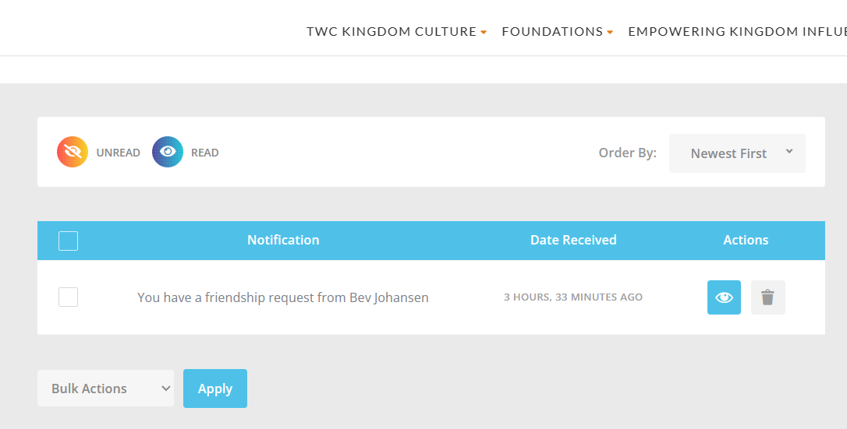
Once you have gone through this process you will be able to use Messaging on the Forum to contact them and get to know one another better.
We have information on the Website to help you in your buddy relationships. You can check out this information under TWC Kingdom Culture/Ways to Connect. Under Forum – General Use Guidelines you will find TWC guidelines and precautions for posting and connecting on the Forum.
Under Warrior Buddy Information you can find information about the benefits of a Buddy and Warrior Guidelines for those connections. Next to Warrior Buddy Information is Problem vs Possibility Conversations where you can find supportive information for learning how to keep your connections Kingdom focused.
You can find a video of the “adding friends” process by clicking on the Forum tab or using this link: Adding friends on the forum.webm on Vimeo

Fire Starters
What is His Presence pouring into you today?
What deposit of grace does God have to help you see who He sees in you?
Do you have a promise that He wants to pour grace into in this next season?
What might the Lord want to give you, reveal to you, or transform within you, as you take initiative to pursue your training and maturity into your Destiny as a Son of God?

What is your intercession in the Key Territory of Empowering Grace activating today?

