Focus: July 2024 Impact Prayer –

River Delta and Currents of Change

**What Is God Revealing?**

**By Christine Casten**

God makes us ready for a new season. This season transitions us into new type of water experience. The beauty of life with God means we move between waterfall, pool of purity and the flowing river with ease. Refresh, growth and change together and easily accessed through a moment with Him.

Consider the imagery and how God moves us from one form of water to the other as a linked tribe. First, a waterfall of blessing pours over us, matching God’s provision of heaven flowing into our lives. He is pouring in His love, nature, and seven spirits expanding our capacity to receive from Him. Then, He immerses us in a pool of purity. This holding space was a secret place of change, a stationary well, where we could consider the things shaken loose or expanded in the prior season. Now, God takes us into a current of flowing water.

This flowing current imagery beautifully matches what the Spirit is doing. With our trust in place, we are ready to have peace in the currents and where they take us. In the process, we have movement because of our peaceful reliance on Him. The landscape passes by and with little effort, we are moving in His flow.

The river I see is swollen and full, but not sluggish. It is moving at a pace that encourages us to hold on and keep our eyes open for the wonder of what is all around us. The river moves with the momentum of rains and water sources converging together. This convergence brings a swirl of blessings, provision, movement and shift.

With a river of this magnitude, we tend to focus on the water. But the water carries the top soil lands it traveled through before this moment. It contains the riches of nutrients that are carried down river, as well as the power to shift and shape the landscape. When it finally reaches the ocean, the silt is deposited in the mouth of the river. The “voice” of the river contains all the riches carried downstream.

We are on the river. We are in the river. We are the river. With this understanding in mind, take some time to understand God’s heart for this season. Open your heart to Him and allow Him to speak through these images into your life. The currents of change are moving. The delta is being expanded. What is God sharing with you in this time?

Promises in the Water

Sharon Rudolph

In the passage 2 Peter 1:2-4, Peter brings to his readers' attention the promises made by God. These promises are described as magnificent and precious in various translations of the text. They serve as a link to sharing in God’s divine essence. The training year’s first Impact Prayer highlights that we exist within the deliberate abundance of God, overflowing with Him just as stated in 2 Peter 1:3. Within this bounty, we have all that we need.

God understands our human need for something to cling to, which is why He provides us with promises to ground our hopes and keep us attuned to His intentions. A promise from God transcends our rational thought and leads us into faith, which is not merely optimistic thought or logical anticipation of a good result. Faith forges a bond with God's intentions and pleases Him, recognizing His nature and His love for us.

As God opens the flow of Himself to us, He controls the intensity to enrich us in the best possible way. Yet, we too can influence this intensity. Being overwhelmed is one emotion many people do not want to navigate so they avoid it or curtail it to something they feel they can manage. In the promises of God and His divine nature are the seeds of faith that that assist us in relinquishing our grip on this divine influx.

In learning to cope with possibilities and the feeling of being overwhelmed, God is carving out a space for us to experience our identity as His children. We are invited to enjoy the simple pleasures, cultivate growth, and engage with God in the territory He provides. Consider who God is for you in this context and which promises or scriptures are guiding your journey. These considerations lay the groundwork for deeper introspection: Assess the amount of love required to accept and move within the realm of God's possibilities and the trust necessary to release control. Reflect on whether any existing promises or scriptural insights shed light on these explorations.

This Impact Prayer is a promise in and of itself. Let it be a launching pad for your asking, seeking, and knocking. (Matthew 7:7-8) You may find yourself in the overwhelm of His endless and ever flowing love!

Coaches Article

Change Is Here

Stacey Beebe

Imagine being one of the disciples, following Jesus for three years, growing in intimacy with the One who loves you, finding calm in His voice, joy in His eyes, and wisdom in His teachings. Then, change came.

Things feel different, unsure, and scary. A few weeks ago, He declared His Authority over you and sent you. Everything changed, especially your identity. You transitioned from disciple to Apostle. Now it is your job to heal, deliver, and teach.

This is when the much-loved child becomes a fully mature adult - Full in Sonship!

This is where the water’s overflow spreads out into new territory, plants fresh seeds, develops green lands, irrigates the thirsty ground, and draws the thirsty people to the Living Water. Scripture says that after this river of change, the disciples became those who “turn the world upside down.” They faced anxiety, struggles, and difficulties, but they had so much more within them than they did before this change.

Instead of losing their Teacher's wisdom and guidance, they had God's overflowing power within them, guiding, directing, and empowering them every step of the way. This empowerment filled them with confidence and a sense of purpose.

Instead of losing the security of His love as they faced opposition, His love beat ever more strongly through their hearts so that the Love of God could reach their opposition. This unwavering love of God not only comforted them but also provided them with unwavering support in the face of their adversaries.

This is our Delta River, our line of demarcation for this season. We have soaked in His heart, been amazed by His thoughts, and been changed by His love. We have risen in the overflow of all He is, and He is sending us out in His power and authority to new territories. This is where He fills us with abundant life that we can no longer keep to ourselves. This is where the power of God through us sets us on a course, riding on His currents, to see the Kingdom of heaven touch the earth around us and turn the world upside down. This is now.

Training Article

Chosen Warriors,

Formerly known as New Members

In Spring 2024, our New Members group was renamed to Chosen Warriors. This title serves as a powerful affirmation from the moment one joins The Warrior Commission. It then opens the door to personal discovery: what implications does being selected by God carry for you? One might initially be unsure how to fully embrace this idea or may only partially believe it. However, by identifying as Chosen Warriors, we make a conscious decision to view ourselves through the lens of divine selection, acknowledging that His choice preceded our own belief and acceptance.

It takes a Warrior’s heart to love like God loves with tenacity, grit, gentleness, and selflessness. We have been chosen to walk this road in Jesus’ footsteps of loving well and giving God the glory. Holy Spirit brings all the resources of heaven to us to help us learn the “how” of being a Warrior Son or Daughter in God’s Kingdom. Your version of Warrior will be unique. Your voice will shine forth God’s design of you all the while giving glory to the one true God.

The Warrior Commission equips you with the tools and practical experience needed to cultivate resilience, resolve, and endurance in your spiritual journey. Developing a strong internal foundation takes time, but once achieved, it can protect you from external pressures and enhance God's Presence within you.

Regardless of where you stand on your path with TWC, you are recognized as a Chosen Warrior. Your training is designed to empower you to become the person God intended. As a Warrior, you will be instilling hope for the future, facilitating restoration with God and others, and actualizing both your aspirations and His visions for you. What commitments are you making to yourself and Him today?

Website Article

Website Upgrades

Some of you may have noticed that the Website is looking different these days. We have had an upgrade that provides us with more options than before but includes some visual changes. Once you log in, the black bar across the top is the same where you can still access **My Account, Warrior Chat,** and **Forum**.

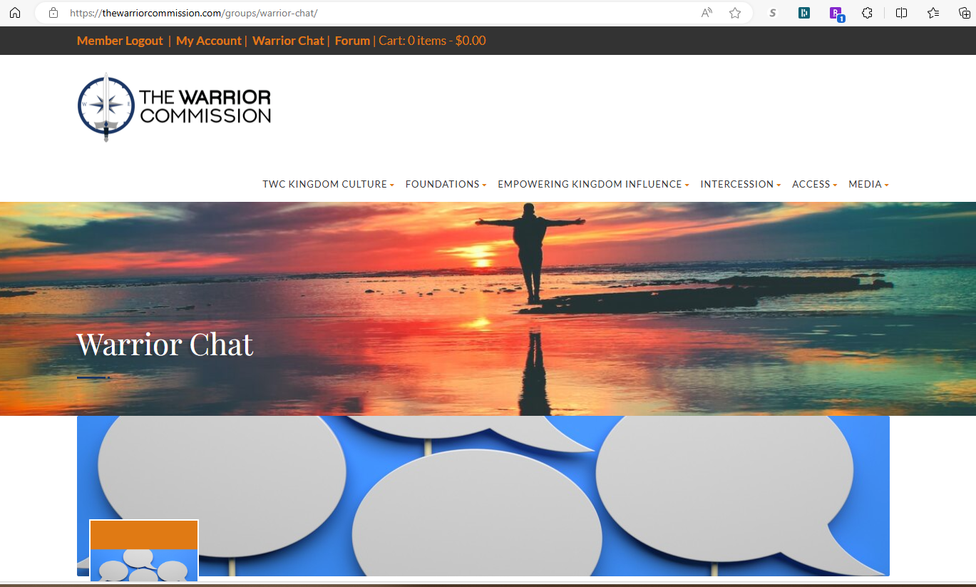

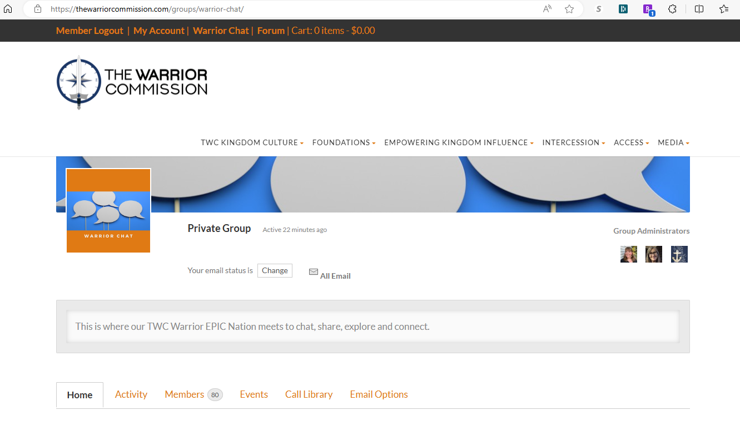

When you click on **Warrior Chat** the page looks like the one above. It is a little different than before. You have a menu bar to help you navigate within the Chat. To see what has been posted, or make your own post, click on Activity. Events and Call Library are the same as before. Click on Email Options and you will have options to set your preference for receiving emails from the Warrior Chat group.

The **Forum** tab from across the top will take you to your account information and give you a list of tabs to access information about your activities and connections within the **Forum**. This is where you find your Friends and the Messages system within the website.

As always, if you have any issues or questions with the Website, you can email our Operations Liaisons at [twc.memberservices@gmail.com](mailto:twc.memberservices@gmail.com), or our Coaches at [twc.warriorepic@gmail.com](mailto:twc.warriorepic@gmail.com).

Fire Starters

The currents of change are moving. The delta is being expanded. What is God sharing with you in this time?

How is God overwhelming you through His endless and ever flowing love?

How is God getting you ready to join in “turning the world” to Him?

What verse is God placing on your heart in this time/season?

How is God helping you keep hope alive?