**Impact Prayer**

**River Delta and Currents of Change (Jul-Dec 2024)**

**“I position you in this flow to intentionally overwhelm you with My bountiful cascade of promise and provision.**

**Your delta is a rich deposit of fertile land. Just as the symbol for delta represents change to a new demarcation of time, you are in a new season within this New Era.”**

**Our Own Quest  
By Christine Casten**

“You can read any book you want. We’ll come back every week to get more,” my mom stated. It was summer and my mom decided my stepsister and I needed to join in the summer reading program at our library.

As I looked at the books lining the walls, I was not sure where to start. After reading many types of genres that summer, I realized I loved the epic quests, including Lord of the Rings and The Chronicles of Narnia.

Something about “the quest” drew me to those books. I devoured them and read them over again. The characters, who didn’t know who they were, found their identity and call. They developed a fellowship and a bond of friendship that could never be broken. Choices made exposed better or weaker character. Perseverance and tenacity were needed for evil was present. Good triumphed over evil.

I never guessed when reading those stories, we would live our own version of an epic quest together in The Warrior Commission. We travel the spiritual landscapes of mountains, plains, space, oceans, waterfalls and rivers of our destiny. We learned to navigate these many terrains and what they represent with God and each other.

God overwhelms us with His goodness. He strengthens us as we face challenges, growth and warfare. He moves through our training to mold and shape us in ways we never imagined. He connects us as a group of amazing Warriors who are learning to be empowered ambassadors of His love.

God positions us in this eternal flow, overwhelmed by what God releases. We each link arms together in the bountiful cascade of God’s promise and provision, personally receiving dots of revelation and then connecting the dots together. We press into what’s possible with God; forerunning, discovering and exploring. We take ground, establish and create with Him, too.

We are in our own quest, together discovering the prophetic promises God has for us. He’s sharpening our spiritual weapons and developing our confidence. No matter the personal call we have, we know that our Warrior Commission quest, this adventure of a lifetime, is ours to travel, record and share.

Thank you for being part of this fellowship of Warriors, we never imagined we would find a more empowering, encouraging and overcoming place to call home.

How does our quest motivate your heart?

What is your part in our quest at this time?

How does walking in your identity add value to the journey we are on together in TWC?

**Time to Explore with God**

**By Sharon Rudolph**

River travel is this great mix of relaxation and planned adventure, whether you are in an innertube on the Chattahoochee, or a raft on the Colorado. We, as The Warrior Commission, have been in and on this river for a couple of months now and things are definitely moving towards something. Do you feel it? Are you stepping out into the rich soil where all of God’s deposits are available? Has He been depositing something into you, or are you being asked to find those deposits in the river? Are you riding the main flow out to the sea where the salt water is made fresh? (Eze 47:8-10) Or somewhere in between?

When you begin to take a look at the word “delta” as it relates to time on and in this river, this new season we are in begins to expand to include way more that water or deposits of soil. The when and how of your interaction with this delta relates to who you are with and to where you are headed in this season of this New Era. A focus on comparison or performance is not helpful here. Being inquisitive and embracing freedom in this space will help you discern what God is up to in and for us. This exploration will produce beautiful tools to support us in our partnership with Him and for living out our identities and commissions.

To fully benefit from this River Delta, whether considering water, soil, or time, our position relative to its source (God's Kingdom) matters as well as whether we are moving with it, or away from it. While we may not know exactly where we are in the river, we can ask questions of ourselves, and of the Lord, like, “What do You want me to know, and what do you want me to do with this?” to begin unpacking all God has for us in this partnership with Him.

As you explore this river delta and are sorting through God’s overwhelming bountiful cascade of promise and provision, there will be new demarcations of time, starting places and ending places. You perception of this Kingdom time impacts the decisions you make for now and for the future. Ask, Seek, and Knock. (Mat 7:7) He wants you to see His lovingkindness for you and for others.

As a reminder, Jesus said He would never leave your or forsake you (Josh 1:5; John 10:28-29) and Holy Spirit is sealed with your spirit (2 Cor 1:22) and will teach you all things (John 14:26). You have got help as you navigate, explore and give the Lord permission to expand you for what He has for you in His love.

Coaches Article

Seeking Joy and Keeping It

By Brigetta Eshleman

As a movement, we in TWC have been thinking about the River Delta as a collective source of identity. We have been thinking about such things as the banks of the river, the strength of the river, and the river delta which becomes rich in mineral deposits. We are also encouraged to think of ourselves as the river. In last month’s Frontline, the activation in the article Flow helps us envisioning ourselves as the river in its majesty and beauty where the Lord can fill us with Himself, His Presence.

Part of the evidence of that Presence is joy. I have been thinking a lot about joy lately. Often it seems that trying to acquire joy can be like trying to catch a butterfly. In Psalm 23, the psalmist is reminded of the goodness of God in a very dark place. Verse 5 says, “you prepare a table before me in the presence of my enemies.” Was the table created so his enemies could see the goodness of God toward him? Yes and no. The table is given primarily to the psalmist. God is saying, “fellowship with me; look I have laid out a banquet before you.” The banquet is for the psalmist while his enemies look on, but the joy of the Lord is for him, and us personally, not just as a way to witness to others. Attending a banquet is a joyful experience and one presented by our loving Father is even better.

I have been reading The Other Half of the Church, by Jim Wilder and Michel Hendricks. They encourage the reader to make a list of experiences that bring them joy particularly when they think about the Lord. This list is to include experiences we have had with the Lord that we can go back to and think about when we need to change our thinking. Some of my experiences are pictures I have seen when praying but others are more concrete like the time I was hiking and saw a scarlet tanager. For the psalmist, he can look back at that moment when the Lord placed a banquet table before him in front of his enemies and think about it again. It warms his heart in that joyful place of rest he has in God.

What would be on your list of experiences that fuel your joyful moments of God’s Presence? What insteads and promises has He deposited in you, over time, to give you heartwarming memories?

Website Article

Connection Options

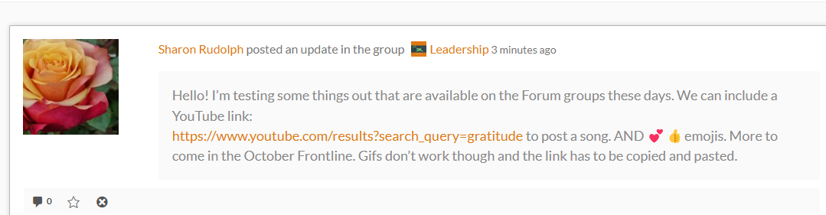

Here are some ideas for posting in the Forum groups like Warrior Chat and your CoNexus Hub group. You can copy and paste a YouTube link or any website link and when you click post, it creates an active link in the post. On my PC/Windows laptop, I realized that when I hit post, it did not automatically refresh itself. I needed to hit the refresh button. If you try to hit the post button a second time it simply posts what you typed up twice.

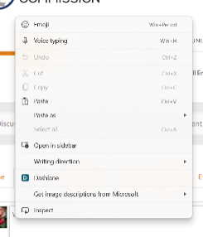For Emojis, for a PC/Windows system: put your cursor where you would like to put in an emoji; right click on your mouse or touch pad you simply RIGHT click on your mouse. A menu come up and you click on the word emoji at the top. Pick the Emoji you want and click on the Post button.

Again, you will need to refresh your page to complete the post. The curly/circle with an arrow is the refresh button on my laptop.

Forum Groups and Warrior Chat are a great way to share your Warrior Journey with your fellow Warriors. What has God done for you lately which you would like to share and give God Praise? Any questions about the website, the Forum, or Warrior Chat can be sent to [twc.warriorepic@gmail.com](mailto:twc.warriorepic@gmail.com), or twc.memberservices@gmail.com

Training Article

As you are exploring this river and what God has for you in this river, you have a wonderful resource in the Call Library. The *Embracing Intercession* calls are there for July, August, and September. October and November will be coming soon. On these calls, Ted Mather is facilitating exploration of the River Delta and Currents of Change Impact Prayer. Listening to these discussions can be very helpful for your own process, no matter what Training Module you are currently exploring. In The Warrior Commission we are often in a both/and on our journeys with the Lord. Our Training blesses our exploration in the community and our exploration in the community blesses our training. You can check out these calls and understand what God might have for you in this river.

Fire Starters

How does our quest motivate your heart?

What is your part in our quest at this time?

How does walking in your identity add value to the journey we are on together in TWC?

What on your list of experiences fuels your joyful moments of God’s Presence?

What insteads and promises has He deposited in you, over time, to give you heartwarming memories?

In regards to our River Delta IP, what do you feel God want us to know about this moment in time?