Flow

by Sharon Rudolph

Imagine a river. You can think about a picture you've seen, or you could even ask the Lord to help you see His Kingdom river where those leaves for the healing of the nations float. (Ez 47:12; Rev 22:2) Now step into this river and journey with the Holy Spirit into its waters flowing from God's throne. You no longer are separate from the water; the water is filling you up, even to the space between your molecules. You are saturated with this water from God that is full of Him and is fully in you.

You have gone beyond being on the water to being in the water, one with it. (John 7:38; John 4:14) Your pores drink it in. Whoever drinks this living water that Jesus gives will not be thirsty for God *and* will be a continual flow to the world around them. The flow from a spring can be powerful, transforming dry soil into fertile ground where seeds can sprout and become plants that nourish and give shade.

Something else the river from that spring can do is change the landscape, moving dirt and rock. Is there anything in your inner landscape you would like to see changed, especially anything that will promote more seed sprouting and life flourishing? The Woman at the Well likely recognized her need for change, but how would it happen? She simply had an authentic conversation with Jesus, drank from His goodness, and He brought about the change. She didn't have to figure it out or make it work; *He* accomplished it within her through her willingness to say yes to Him. Then she had the privilege to walk out that change so it became hers forever.

Being in this river engages our inner landscape as the Lord expands our partnership with Himself (His living water) to manifest what glorifies Him. We have our own "Woman at the Well" stories, some historical and some ongoing, where we have said yes, and our inner landscape changed. His water brings forth His design in our unique human lives.

During your journey what have you uncovered about God's design of you, your identity as a Son/Daughter of God? Where do you think He is taking you? Have you given Him a *yes* to the internal landscape work He knows will bless you? How are His currents bringing the landscape change for which you are thirsty? This river journey is a beautiful ongoing place to rejoice. Be thankful and full of gratitude for all that has come before, and all that is ahead, moving with the flow of God, always a blessing, always good.

Coaches Article

Confident Expectation

Alma Copenhefer

I’ve been pondering the idea of how to navigate this new season of “Currents of Change''. I believe that this season brings to the forefront an activation of the precious promises, provision, and possibilities “which He has freely given us in the One He loves.” (Ephesians 1:6) I thought about David, a man after God’s heart, a friend of God, a servant of the Most High, and a highly favored son. Could it be that David, navigating his personal currents of change, was birthed through his confidence in God’s Spirit of Sonship and Grace?

The flow of these currents of change took David into unfamiliar territories with wide, steep, rocky, and at times very lonely, treacherous terrain. David had a profound sense of God’s faithfulness and a deep understanding and confidence of God’s limitless love and favor. God’s Spirit of Sonship anchored David in his inheritance. David knew God would see him through the challenge of facing Goliath, being a fugitive from Saul, ruling the nation of Israel, and more personally facing the dysfunctions within his family. David’s strength and success was fully backed by the God of the Angel Armies!

David knew that nothing would separate him from the love of God and that in any battle, there were “more with him”. Even when he fell short and stumbled into sin, God was able to make grace abound so that “in all things at all times, David would have all that he needed ''. (2 Cor 9:8) So as we navigate this new season of “Currents of Change '' let us hold fast to His faithfulness to us as His heirs, sons and daughters, and His grace upon grace. Can you feel the wind blowing in your face and the bursting forth of our readiness to take on the new terrain? The fruitfulness in this territory will flourish only through our confident expectation of God’s goodness, faithfulness, and grace.

Website Article

Getting Notifications about Forum Posts

The Forum on the Website is being updated. Improvements are coming. Since the time we migrated to a new server in June, I realized that I was not getting emails notifications that someone had posted in my personal email address. While I don't have time to watch the Forum all the time, I love reading posts and having an option to comment back.

Replying with a comment is a great way to get your Warrior Voice out there. Each time you write your comment, thoughts are being solidified. With each word you testify to, declare and celebrate God’s goodness. It reinforces His faithfulness to you and encourages someone else to read of your journey, pressing in and breakthroughs.



Once you log in and click on Warrior Chat, this comes up. I have a green box around the place where you can make the change. You can see that my current status is All Email. Even if you don't need to change this status, for right now, go ahead and click change and reset it. If something from the website updates is not reading your preference correctly, resetting this status should correct that.

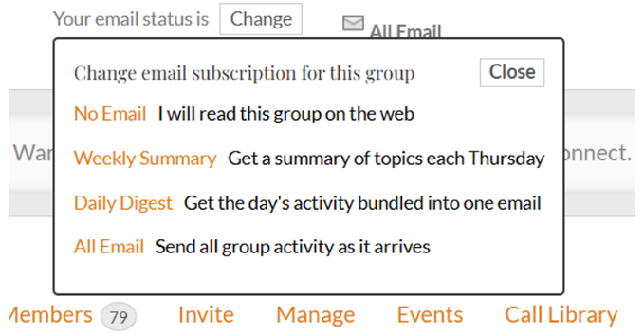To make a change or a reset of your current change, simply click on the Change button. Then this menu will come up.

Now you can pick the email notification rate that suits you best. You will get a notice like this once the change/reset has been made.

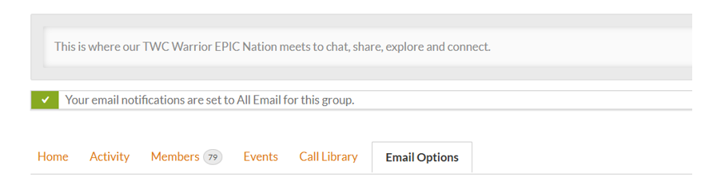

If you are in more than one group, you can click on Forum, then Groups, and all the groups come up in one place. Then you can scroll through and make adjustments where you like.

Logging In to the Website *(Not sure this section is necessary now)*

Some of you may have notice issues with Logging In to the Website. If the website has temporarily shut down, you will get this notification on the screen:



If this come up, please click on the Member Login button in orange, and you should be taken to the correct log in screen to access the TWC Member side of the site. If the Website is under construction because our web designer is updating it, you will get an **Under Construction** sign. If you have other website issues, please email twc.memberservices@gmail.com and help will be available soon.